**Chapter 09-02: Integrated WM Process Execution**

|  |
| --- |
|  |

|  |
| --- |
| **MOTIVATION**  In this exercise, you will do the following for WM Procure from Plant Integrated Process:   1. Create Appropriate Master Data 2. Begin Fulfillment Process 3. Begin Procurement Process 4. Production Process 5. End Procurement Process 6. End Fulfillment Process |

|  |
| --- |
| **PRODUCT**  SAP S/4 HANA 1709 |
|  |
| **REVISED**  07/14/2020 |
|  |
| **FOCUS**  Procurement  Fulfillment  Production  WM |
|  |
| **AUTHORS**  Simha R. Magal  Jeff Word |
| **VERSION**  1.4 MCC  **TESTED**  07/14/2020 |

|  |
| --- |
| **ACKNOWLEDGEMENT**  These are the GBI exercises developed by Simha R. Magal and Jeff Word.  These exercises include concepts discussed in the book, *Integrated Business Processes with ERP Systems* (Epistemy Press, 2012). |

|  |
| --- |
| **PREREQUISITES**   1. You should be familiar with navigation in SAP ERP 2. Completed Exercises Chs. 02-01 through 07-04 |



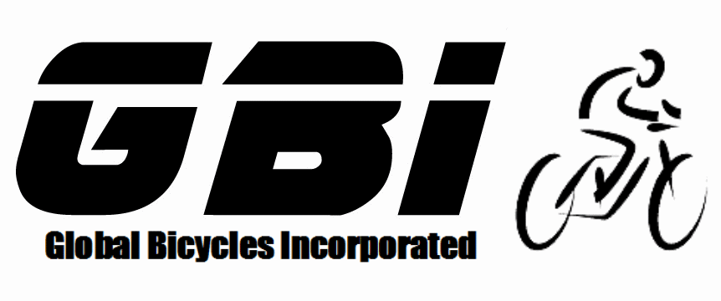

© 2020 Epistemy Press, LLC.

Screenshots © 2020, SAP SE

1. Table of Contents

Table of Contents

Section 1.1: Create Appropriate Master Data **Error! Bookmark not defined.**

Section 1.2: Begin Fulfillment Process 5

Section 1.3: Begin Procurement Process 6

Section 1.4: Production Process 8

Section 1.5: End Procurement Process 9

Section 1.6: End Fulfillment Process 10

* Before you begin this exercise, you must ask your professor if they would like you to clear out your inventory, or if they would like you to assume that you have none of the necessary inventory.
* If Inventory needs to be cleared out you may use movement type 562 in transaction code MB1C to clear out your Dallas Plant. However, movement type 562 will not work in a plant that is warehouse managed (San Diego). You must complete the fulfilment process to clear out your San Diego Plant. You only need to clear out your Dallas and San Diego plants.
  1. Create Appropriate Master Data

The purpose of the chapter 9 exercises is to bring together everything you have learned throughout the course. There will be very limited instructions provided as you should be referencing previous exercises whenever you are unsure of what to do. You will be required to do more than what is specifically stated in the exercise.

* Before you start the entire cycle, you need to create the following master data beforehand. Notice that some master data is already created in the system from the previous exercises.
* Copy from the original Spy Gear vendor to create your own Spy Gear vendor.
* Copy from the Original Northwest Bikes customer to create your own customer.
  + You will need to create this customer twice.
    - 1) Create the customer using your West Sales Organization, the Wholesale Distribution channel, and Bicycles Division.
    - 2) Create this customer using your West Sales Organization, the Wholesale Distribution channel, and the Accessories Division.
  + Use San Diego as the delivering plant
* Copy from the Original Off-Road Helmets Trading Goods to create your own trading good.
  + Create the trading goods using views:
    - Basic Data 1
    - Sales: Sales Org. Data 1
    - Sales: General/Plant Data
    - Warehouse Management 1
    - Purchasing
    - Accounting1
  + Within San Diego, use your West Sales Organization, Wholesale Distribution channel, Your Warehouse, and Shelf Storage as the Storage Type.
  + Use San Diego as the delivering plant.
  + Use Your Purchasing Group
* Copy from the Original Silver Deluxe Touring Bike finished good to create your own finished good.
  + Create the finished good using views:
    - Basic Data 1
    - Sales: Sales Org. Data 1
    - Sales: General/Plant Data
    - Warehouse Management 1
    - MRP 1
    - Accounting1
  + Within San Diego.
  + Use your West Sales Organization, Wholesale Distribution, and Pallet Storage.
* Create pricing conditions for your Silver Deluxe Touring Bike and Off-Road Helmet.
  + Price Your Bike at 2800 for your US West Sales Organization.
  + Price Your Off-Road Helmet at 50 for your US West Sales Organization.
  1. Begin Fulfillment Process

In this section, you received a Purchase Order from Northwest Bikes for Five Deluxe Touring Bikes (Silver) and Fifty Off-Road Helmets in San Diego. The Purchase Order document number is 0##-42660. You will begin fulfilling this order by creating a quotation. It may help you to refresh your memory that within GBI US, although you have previously fulfilled from San Diego, San Diego buys and sells while Dallas produces.

* The Sales quotation will be using the West Sales Organization and the Bicycles Division.
* Reference the Sales quotation document number to create the Sales Order.
* During this process, you will be brought to a screen titled *“Standard Order: Availability Control”* Click on the “Continue”  icon through both screens until you reach the *“Create Standard Order: Overview”* screen. These screens are indicating the fact that the quantity ordered is larger than how much inventory is on hand. We will address this in the last step for this exercise after your inventory is filled.

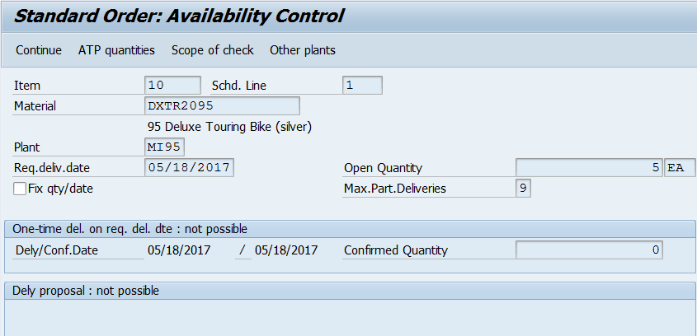

1. What is the Sales Quotation document number?  
          🖉
2. What is the Sales Order document number?  
          🖉
   1. Begin Procurement Process

In this section, you procure the required materials to fulfil the customer Purchase Order. You will need to procure all the Raw Materials and trading goods needed to fulfil this order. At your convenience, you have a vendor that sells Off-Road Helmets and another vendor that sells all Raw Materials for your bike. These vendors are Olympic Protective Gear and Spy Gear respectively. Materials are listed in the BOM for the silver bike which is shown at the end of this document.

* Be sure to check your material inventory before doing anything so that you only procure the amount of materials that you will need to fulfil the order.
* Note that from a Raw Materials perspective, the fact that we are procuring all Raw Materials is not normal. Normally, a company would procure required materials from multiple vendors.
* DO NOT use movement type 561 (“inventory from heaven”) to acquire these materials!
* Create a Transfer Order to move your trading goods into your storage bin. This step represents an intersection between inventory management and warehouse management. The system recognizes that there are goods that have been received and need to be put away.
* Use Chapter 04 as a reference and create a Purchase Requisition for Your Off-Road Helmets and another Purchase Requisition for all Raw Materials necessary to produce a bike. Everything will be included in two requisitions due to the simple fact that we are going to be ordering from two separate vendors. Each of these will be converted into Purchase Orders.
* Use the pricing chart at the end of the document for your Purchase Order
* The required Raw Materials for the bike and wheel assembly are at the end of this document.
* Remember to think carefully about the city to which each material should be sent. For example, you are not going to order any helmets into Dallas as it is only used for production.

1. What is the Purchase Requisition document number for Off-Road Helmets?  
          🖉
2. What is the Purchase Requisition document number for Raw Materials?  
          🖉
3. What is the Purchase Order document number for Off-Road Helmets?  
          🖉
4. What is the Purchase Order document number for Raw Materials?  
          🖉
5. What is the Goods Receipt document number for Off-Road Helmets?  
          🖉
6. What is the Goods Receipt document number for Raw Materials?  
          🖉
7. What is the Transfer Order document number for Off-Road Helmets?  
          🖉
8. What is the Invoice document number for Off-Road Helmets?  
          🖉
9. What is the Invoice document number for Raw Materials?  
          🖉
10. What is the Payment document number for Off-Road Helmets?  
           🖉
11. What is the Payment document number for Raw Materials?  
           🖉
    1. Production Process

Now that the Raw Materials are in stock, you can begin the production process. Reference Chapter 06 to help with this section.

* Check to make sure all Raw Materials are in the proper locations for production.
* Be sure that you are selecting the correct item on the stock/requirements list and the appropriate materials are going to and from the proper storage locations for production.

1. What is the Planned Order document number for the semi-Finished Product?  
          🖉
2. What is the Production Order document number for the semi-Finished Product?  
          🖉
3. What is the Goods Issue document number for the semi-Finished Product?  
          🖉
4. What is the Goods Receipt document number for the semi-Finished Product?  
          🖉
5. What is the Planned Order document number for the Finished Product?  
          🖉
6. What is the Production Order document number for the Finished Product?  
          🖉
7. What is the Goods Issue document number for the Finished Product?  
          🖉
8. What is the Goods Receipt document number for the Finished Product?  
          🖉
   1. End Procurement Process

In this section, you finish the procurement process by transporting the Deluxe Touring Bike (Silver) from Dallas to San Diego. You also create a Transfer Order to place the Deluxe Touring Bike (Silver) into your warehouse storage bin.

* San Diego is requesting the Deluxe Touring Bike (Silver) from Dallas, to receive these Deluxe Touring Bike (Silver) into San Diego you will create a Stock Transport Order. Remember, Dallas is the only plant that produces and does not distribute goods to customers, so we must send the Deluxe Touring Bikes (Silver) to San Diego to fulfil the Sales Order. Recall from Chapter 07 on how to make a Stock Transport Order.
* You must move the goods from finished goods inventory into your storage bins in San Diego.

1. What is the Stock Transport Order document number for the Deluxe Touring Bikes (Silver)?  
          🖉
2. What is the Goods Issue document number for the Stock Transport Order?  
          🖉
3. What is the Goods Receipt document number for the Stock Transport Order?  
          🖉
4. What is the Transfer Order document number for the Deluxe Touring Bike (Silver)?  
          🖉
   1. End Fulfillment Process

In this section, you end the fulfilment process by sending shipment and Invoice to your customer.

To tell the system that you now have sufficient inventory to fulfil the Purchase Order sent by your customer, it is highly advised to go back to your Sales Order to note the required delivery date you have entered and to make sure that multiple schedule lines disappear for all your materials. This is done in “Availability Check”. But if you already have inventory the ATP check will not be displayed. “Availability Check” will only appear if you have no inventory.

* + 1. In the *“SAP Easy Access”* screen, follow the navigation path below:

Navigation

SAP Easy Access Menu 🡪 Logistics 🡪 Sales and Distribution 🡪 Sales 🡪 Order 🡪 Change

* + 1. In the *“Change Sales Order: Initial Screen”* screen. Enter the following information:

|  |  |  |
| --- | --- | --- |
| **Attribute** | **Description** | **Data Value** |
| Order | Uniquely identifies the sales document | *Your Sales Order Document Number* |

* + 1. Click Continue C:\Users\user\Desktop\GRA- Dr. Magal\Process Exercise snippets\Continue.PNG.
    2. In the *“Change Standard Order: Overview”* screen, Click Select All  at the bottom of the screen.
    3. Click Check Item Availability .
    4. In the *“Standard Order: Availability Control”* screen. Click Complete dlv .
* You will receive a message that says, “Availability check was carried out”.
* You are performing this for both materials.
  + 1. Click Complete dlv .
* You will receive a message that says, “Availability check was carried out”
  + 1. In the “Change Sales Order: Overview” screen, click Save C:\Users\user\Desktop\GRA- Dr. Magal\Process Exercise snippets\save.PNG.
* You will receive a message that says, “Standard Order has been saved”.
* This will now allow you to create the Outbound Delivery regarding your Sales Order.
* Remember that since you are taking your items out of your warehouse, do not enter anything in the “Picked” quantity column. Use Chapter 07 as a reference to complete this exercise.

1. What is the Outbound Delivery document number?  
          🖉
2. What is the Transfer Order document number for picking materials?  
          🖉
3. What is the Invoice document number?  
          🖉
4. What is the Payment document number?  
          🖉

1. Exercise Deliverables

**Name:**

**Course and Section:**

**Identifier:**

**Client:**

1. What is the Sales Quotation document number?  
    🖉
2. What is the Sales Order document number?  
    🖉
3. What is the Purchase Requisition document number for Off-Road Helmets?  
    🖉
4. What is the Purchase Requisition document number for Raw Materials?  
    🖉
5. What is the Purchase Order document number for Off-Road Helmets?  
    🖉
6. What is the Purchase Order document number for Raw Materials?  
    🖉
7. What is the Goods Receipt document number for Off-Road Helmets?  
    🖉
8. What is the Goods Receipt document number for Raw Materials?  
    🖉
9. What is the Transfer Order document number for Off-Road Helmets?  
    🖉
10. What is the Invoice document number for Off-Road Helmets?  
     🖉
11. What is the Invoice document number for Raw Materials?  
     🖉
12. What is the Payment document number for Off-Road Helmets?  
     🖉
13. What is the Payment document number for Raw Materials?  
     🖉
14. What is the Planned Order document number for the Semi-Finished Product?  
     🖉
15. What is the Production Order document number for the Semi-Finished Product?  
     🖉
16. What is the Goods Issue document number for the Semi-Finished Product?  
     🖉
17. What is the Goods Receipt document number for the Semi-Finished Product?  
     🖉
18. What is the Planned Order document number for the Finished Product?  
     🖉
19. What is the Production Order document number for the Finished Product?  
     🖉
20. What is the Goods Issue document number for the Finished Product?  
     🖉
21. What is the Goods Receipt document number for the Finished Product?  
     🖉
22. What is the Stock Transport Order document number for the Deluxe Touring Bikes (Silver)?  
     🖉
23. What is the Goods Issue document number for the Stock Transport Order?  
     🖉
24. What is the Goods Receipt document number for the Stock Transport Order?  
     🖉
25. What is the Transfer Order document number for Deluxe Touring Bike (Silver)?  
     🖉
26. What is the Outbound Delivery document number?  
     🖉
27. What is the Transfer Order document number for picking materials?  
     🖉
28. What is the Invoice document number?  
     🖉
29. What is the Payment document number?  
     🖉

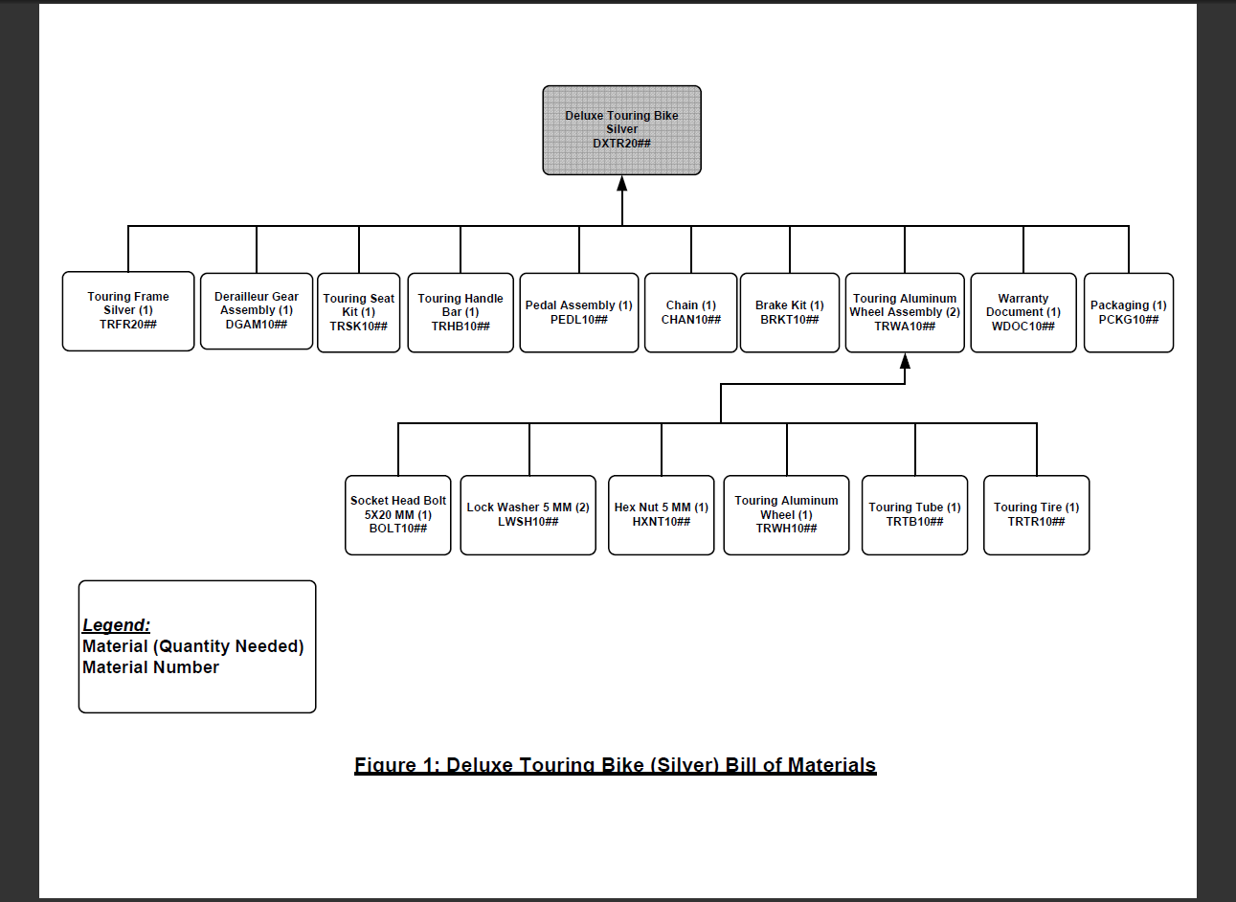

|  |  |
| --- | --- |
| **Description** | **Net Purchasing Price** |
| Off-Road Helmet | $25.00 |
| Socket Head Bolt 5x20mm | $0.10 |
| Lock Washer 5 mm | $0.05 |
| Hex Nut 5 mm | $0.10 |
| Touring Aluminium Wheel | $95.00 |
| Touring Tube | $5.00 |
| Touring Tire | $10.00 |
| Touring Frame-Silver | $200.00 |
| Derailleur Gear Assembly | $75.00 |
| Touring Seat Kit | $50.00 |
| Touring Handle Bar | $25.00 |
| Pedal Assembly | $45.00 |
| Chain | $10.00 |
| Brake Kit | $70.00 |
| Warranty Document | $1.00 |
| Packaging | $3.50 |